PROFILE OF A GUPPY BREEDER #14
Frank Schulterbrandt
Did You Say Computers
Frank Schulterbrandt 4/23/2016
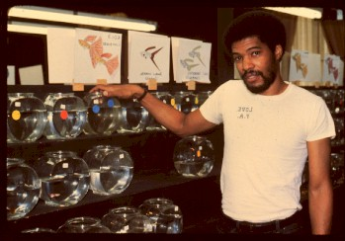
I could tell my story but you have already read part of my history by reading the article which I wrote back in 1997,
The Makings Of A Guppy Addict and Breeding Guppies After a 10 Year Layoff "For The Love Of Guppies". I have enjoyed the hobby of tropical fish for more than 5 decades, in particular the breeding , raising and showing of fancy guppies. I have had great success with African Cichlids from Lake Tanganyika but have always come back to fancy show guppies.
My profession has been in the computer world decades before the first PC became affordably available to the retail consumer. I have been a computer programmer since I was 19 years old. I have used these programming skills to assist in the fancy guppy hobby. I once requested that we have a uniform IFGA coding standard for the guppy show entries at IFGA shows. Once a club accepted the proposed standards I would generate a complete set of show books (Even and Odd show books, Judging result cards and Even and Odd bowl show entry labels) for free. In the early 1990’s I would create the first complete computerized entry show system. Most exhibitor’s names and address info would be pre-loaded into the computer and each exhibitor was assigned a show ID number. When the exhibitor’s entry form was entered he would get his labels printed out on one of the printers and the other printer would print out their updated entry form. Results would be printed along with the judges that judge that color class and awards (1st thru 4th) would be printed with the exhibitor’s name and the amount of entries and judges names.
Years later I would create the South Jersey Guppy Group web page which had a forum and a chat room (the world’s first chat room for tropical fish). The South Jersey Guppy Group web page also hosted web pages for the following clubs for free as they did not have web pages (East Coast, Florida and two more clubs which names escapes me).
The SJGG web site would also be used for the world’s first online guppy club and the first IFGA online guppy club, Guppies International. Guppies International had monthly meeting with guess speakers. Guppies International would provide a means of being connected to other breeders from around the world via the chat room. We brought a few more members into the IFGA some winning color class championships. Guppies International had 25 online paid members. I still have my Guppies International purple shirt with fuchsia letters and a guppy.
The SJGG website would be the functional prototype for the IFGA web page as I and a Ken Jones (SJGG member) created this IFGA web page which also had a forum along with its chat room.
My latest contribution to the guppy hobby is writing articles about guppy events in the past, knowledge that I have collected over the years and most of all trying to tell the story of hobbyist of today and yesteryear. These articles can be found on the South Jersey Guppy Group web page in the Article Archives section.
After a 10 years absence from the Breeding, Raising and Showing of fancy guppies I am back. Writing about guppies and showing them as well. So all I have to share with you now is some photos that I will be adding to this article as I convert some of my 35 MM color slides, which will be some task as I have at least 1000+ 35 MM color slides. So come back once in a while to see any updates…..
I have also been president of four different IFGA clubs. To this day I am always one of the first to be-friend all newcomers. I take a special interest to see if I can get them to stick around and make them feel at home, you never know where the next good hobbyist is going to come from….
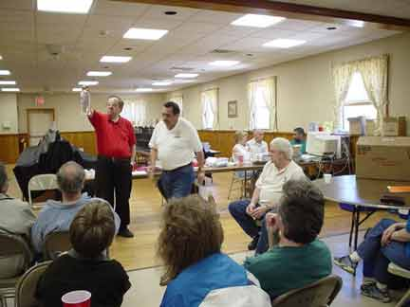
Note the computer system to the right with me in the green shirt in front of the computer monitor.
I am having a conversation with Stan and Ethel Shubel.
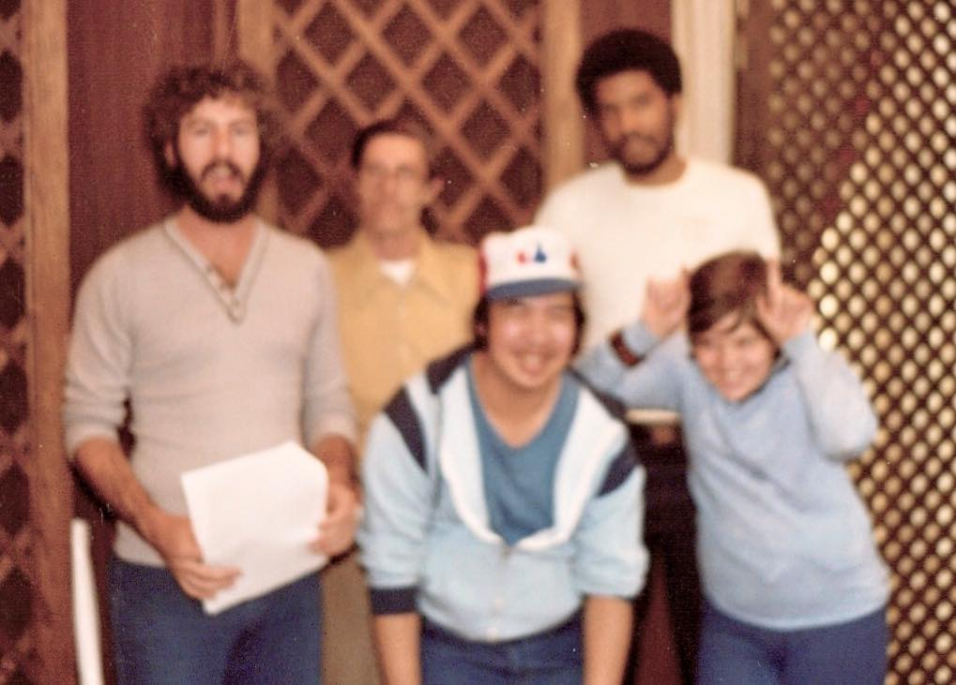
Some of the members from the Big Apple Guppy Group(which was one of the guppy clubs that I created). From Left to right Steve Kwartler, Warren Burke, John Eng, Frank Schulterbrandt and Danny G. (our junior member).
This club went on to win “GUPPY CLUB OF THE YEAR” award presented to BAGG as we had 6 different breeders in the IFGA Grand Overall Standing. We won this in the awards third year from the East Coast Guppy Association club.
And a afterthought: Steve Kwartler and I were not one of the ones in the Grand Overall standings(Steve Out of the hobby at the time and I was just too busy with a ton of things including running the club).
The Big Apple Guppy Group had four IFGA shows in a row, including a meeting show and a IFGA annual show.
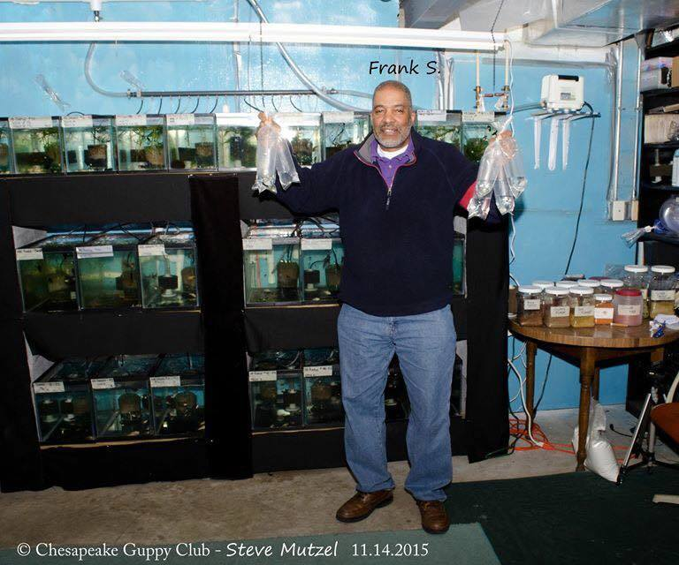
This is what happens in this hobby, I donated 4 trios of guppies to the Chesapeake Guppy Club
and Steve Mutzel would not let me leave without taking two trios of his award winning guppies.
One trio was a donation by Steve to the South Jersey Guppy Group which met the following weekend.

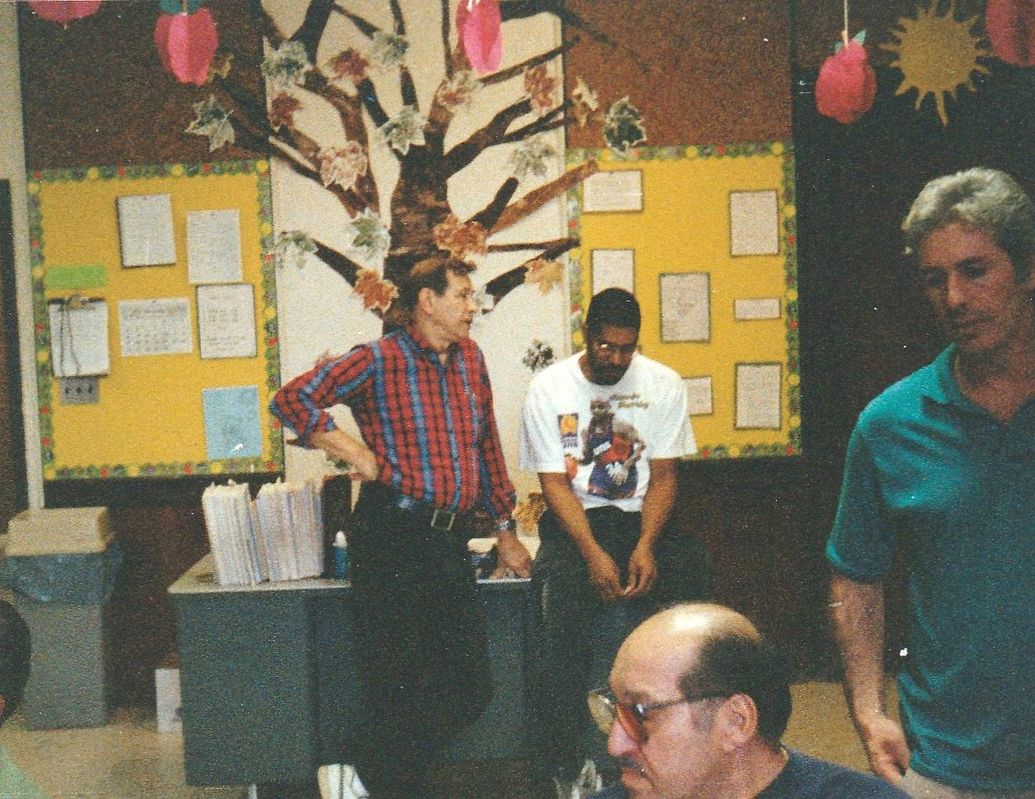
And to think of it, it was just yesterday … LOL ….
Paul Gorski, Frank Schulterbrandt, ? and Steve Kwartler
My present fish room 135 tanks (2016)
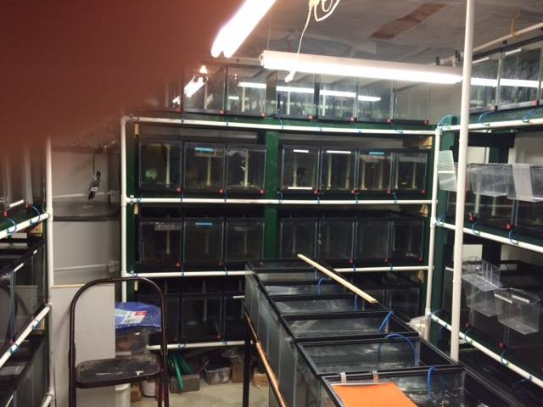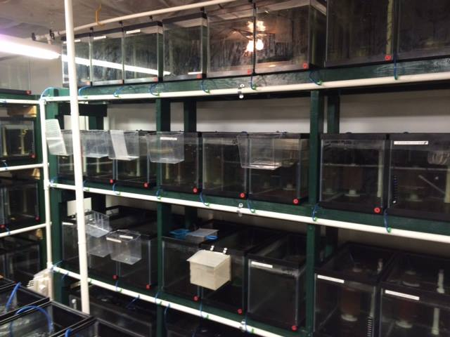
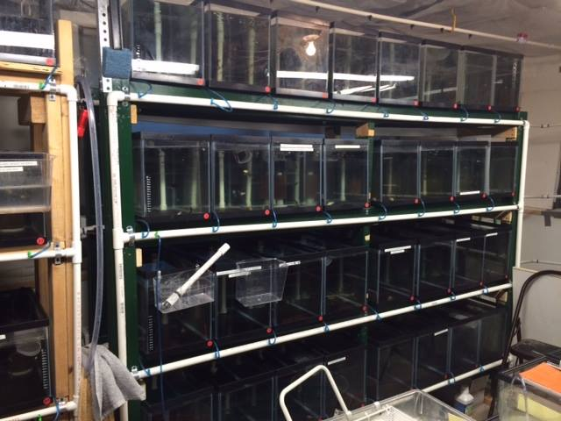
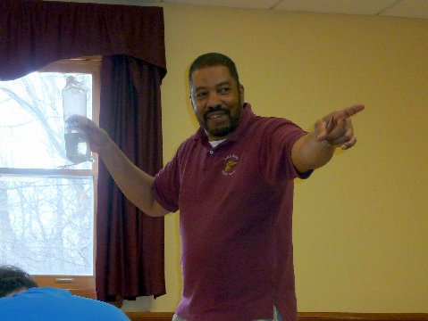
South Jersey Monthly auctioneer
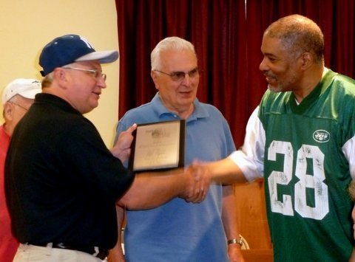
Me presenting awards to three well deserved SJGG long time members(Ron Rapka, Jesse Diaz and Sal Raguso).

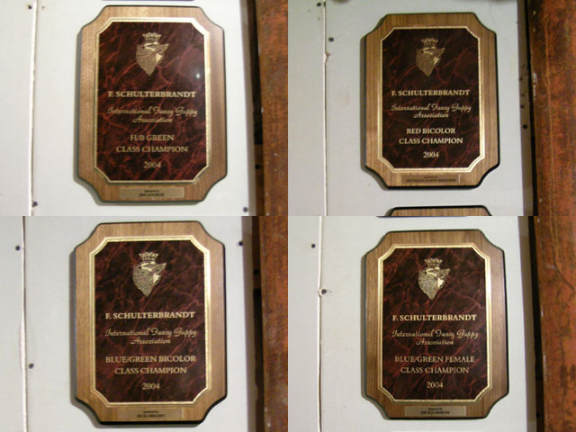
Four IFGA Color Class Championships the year 2004.
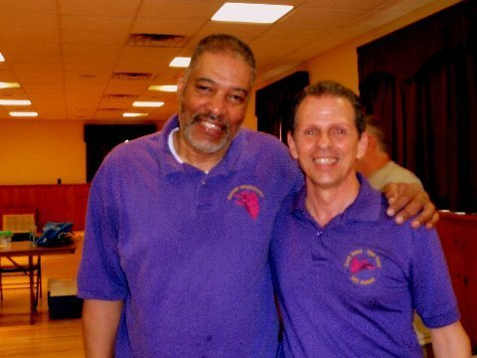
Frank Schulterbrandt (with Guppies International shirt) and Michael Totaro (South Jersey shirt)
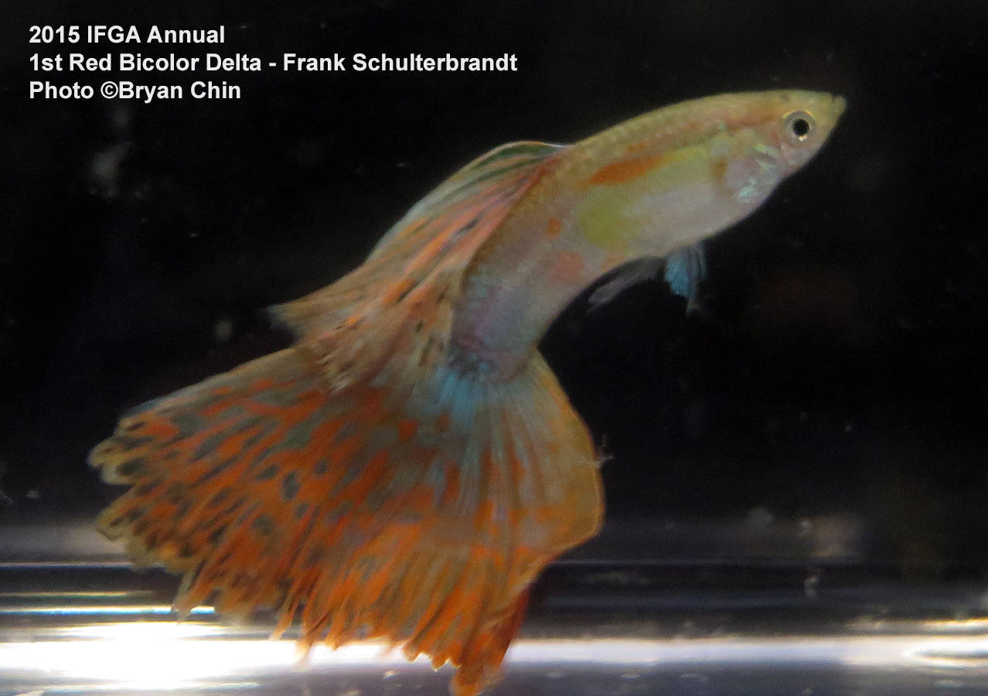
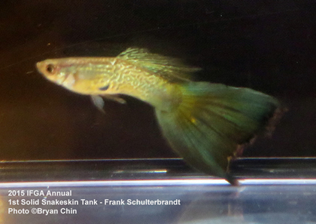
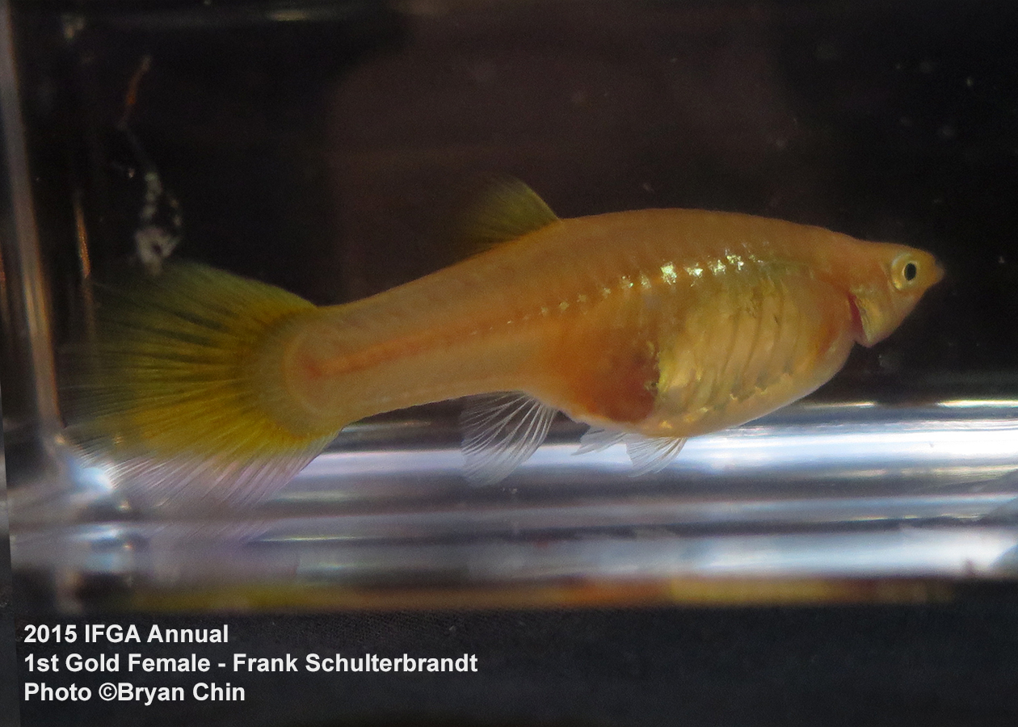

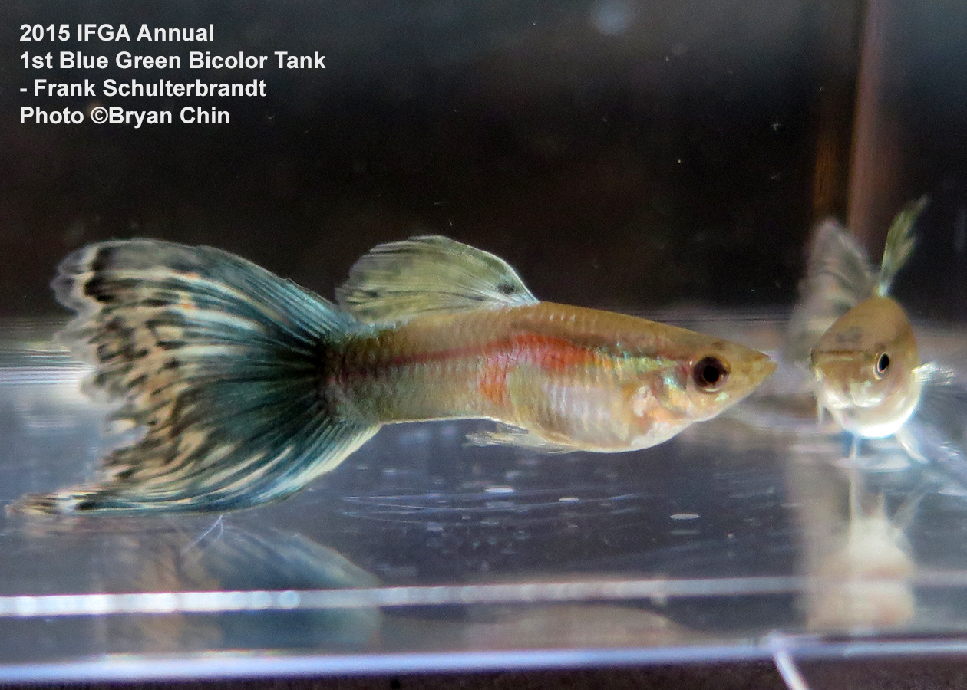
Multi with nice colors in dorsal (work in progress)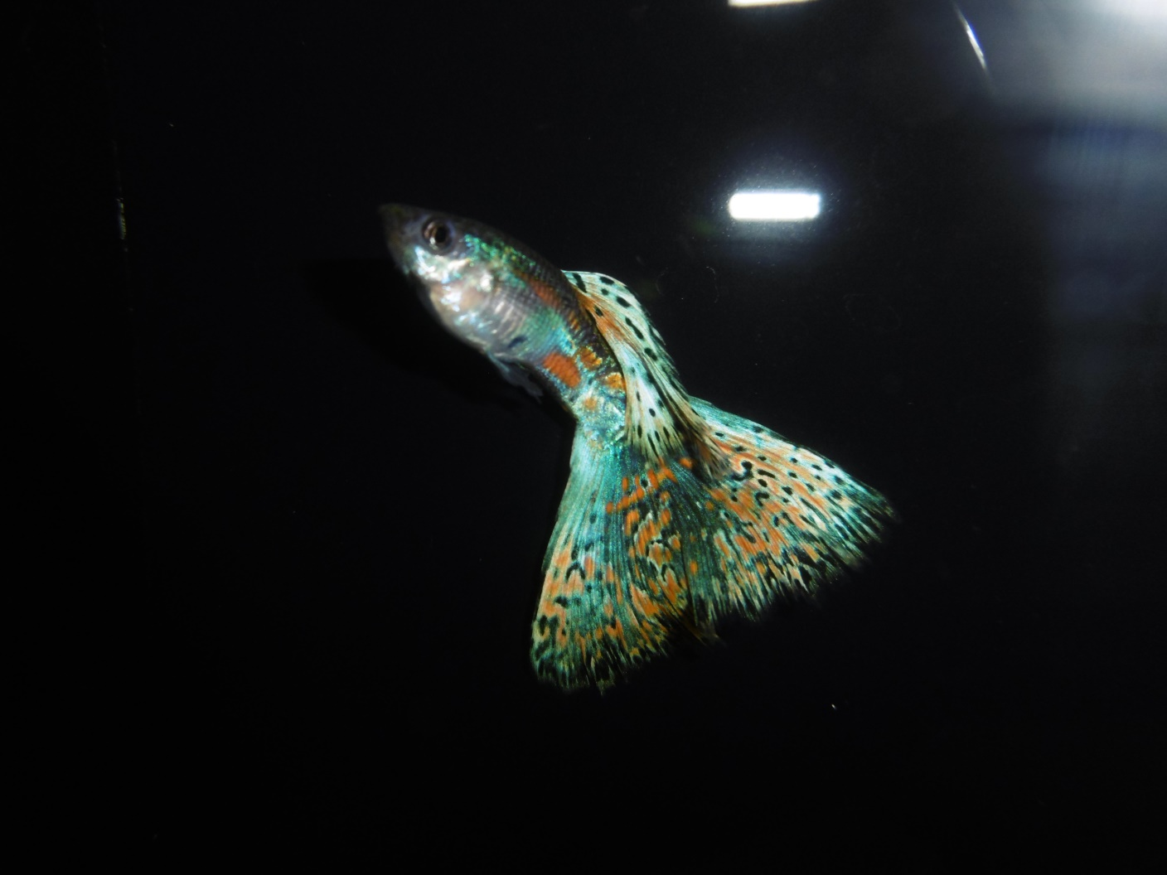
Multi with dorsal color problems (Line B) but larger body size (work in progress)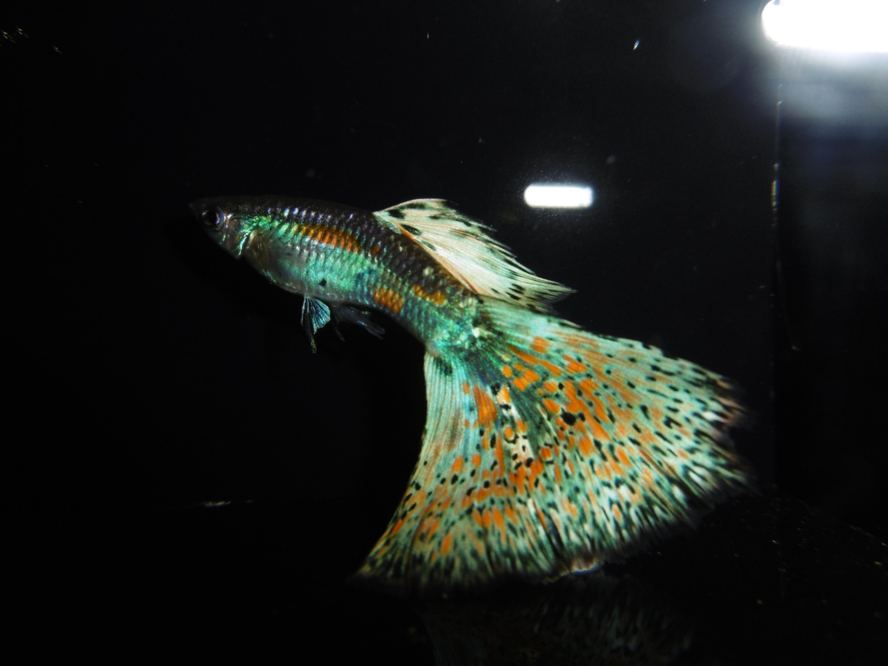

This was some old screen shots from my old hard drive. When I created the IFGA web page and was the web page master. Also is what the IFGA web page had in it.
